Format of the Abstract (one-page maximum): Use A4 Paper Size with 2.5 cm (1 inch) Margins, Arial Font, and 1.15 Spacing

A. Author,* B. Author, C. Author (if more than one, presenting author first with *)

Address or Addresses, with Countries
Email: presentingauthor@address

The 2024 meeting of the above popular conference will be held on April 22-26, 2024, in the Protaras region of the southeast of the island of Cyprus in the eastern Mediterranean. This joint meeting is designed to allow us all to enjoy a broad program spanning many applications of paramagnetic ions (i.e., not just magnetism talks). On behalf of the organizing committee, it gives me great pleasure to invite you to be a speaker at this meeting.
The NAGC conferences alternate between Cyprus and Greece, and occasionally Florida. They were originally established to provide a regular forum for the faculty and students of universities in Greece and Cyprus to meet and interact with their North American counterparts, but they have since grown to become one of the most popular series of conferences involving scientists from North America, the Mediterranean, and elsewhere. Following the outstanding success of the previous NAGC meetings, we shall once again be organizing a broad program that will bring together a range of researchers working in diverse fields and applications who might not normally attend the same meeting [1].

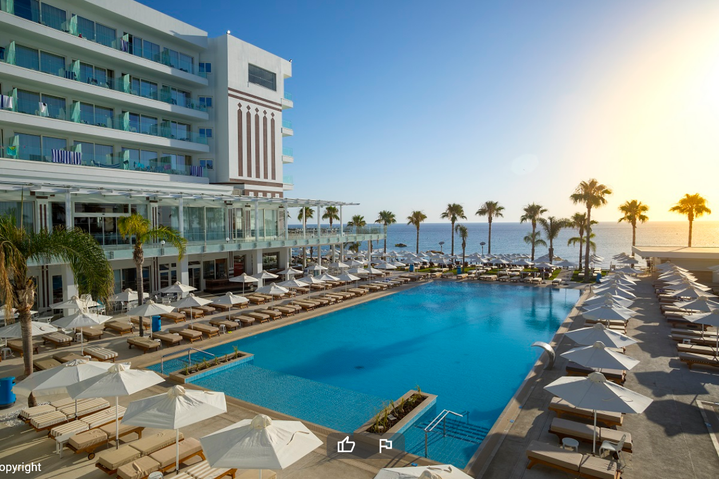

Figure. One figure, if you wish. Constantinos the Great Hotel.

The event will begin with a welcoming reception on the evening of April 21, 2024. The talks will begin on the morning of April 22, and finish in the afternoon of April 26. The talks will be 30 mins (15 mins for students), and there will be no parallel sessions, plenary lectures, or poster sessions.

[1] One or two references, if you wish: authors, journal, year, volume, page

(DELETE THESE LINES)
Email Abstract to nagc2024@gmail.com and Cc: christou@chem.ufl.edu
Submission deadline: March 15, 2024

