Format of the Abstract (one-page maximum): Use Letter Paper Size with 2.5 cm (1 inch) Margins, Arial Font, and 1.15 Spacing

A. Author,* B. Author, C. Author (if more than one, presenting author first with *)

Address or Addresses, with Countries
Email: presentingauthor@address

The 2022 Molecular Magnetism in North America (MAGNA 2022) conference will be held on May 2-4, 2022, at the Hotel Indigo in Gainesville, FL in the new Celebration Pointe development on the south side of the city. The conference will begin with a welcoming reception on Sunday evening, May 1, and the program will then span three full days, Mon-Wed, May 2-4. The program will consist of talks by senior people (30 mins) as well as a number of shorter talks (15 mins) by junior people (students and postdocs). There will also be a poster session on Monday evening, May 2, and a conference dinner on Tuesday, May 3.
I hope that you will be able to attend MAGNA 2022. Please also consider sending one or more of your students to the meeting - we want the MAGNA meetings to be a forum for the development of the next generation of our community, so students/postdocs will have both poster and oral presentation options (more details later). To help with student travel and registration costs, we have initiated an aggressive search for sponsorship, and we are hopeful that significant support for all student presenters will be available.
For maximum benefit to everyone, it is hoped that senior speakers will include a tutorial component to their talks, perhaps 10-15% of the allocated time. We are also hoping to have many students and postdocs attend and will try to ensure that as many as possible are included on the program.

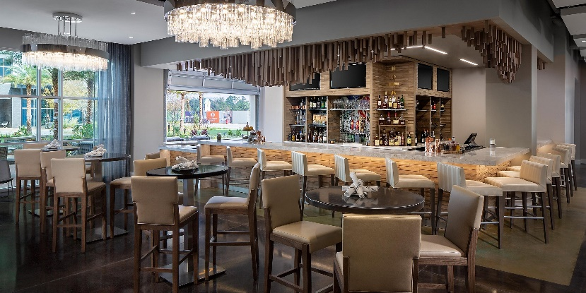

Figure. One figure, if you wish. Hotel Indigo bar area.

[1] One or two references, if you wish: authors, journal, year, volume, page

