Format of the MAGNA Abstract (one-page max): Use Letter Paper Size with 2.5 cm (1 inch) Margins, Arial Font, and 1.15 Spacing

A. Author, B. Author...(if more than one, presenting author first and underlined)

Address or Addresses
Email: presentingauthor@address

Molecular magnetism (MM) – including associated molecule-based (1D-3D) magnetism - comprises a wide range of systems of immense fundamental importance to many contemporary and emerging technologies spanning electronics, spintronics, classical and quantum information processing, quantum sensors, and others. Magnetism is thus a truly multi-disciplinary area whose efficient prosecution requires effective collaboration and cross-fertilization between appropriate personnel: chemists and physicists, experimentalists and theorists, scientists and engineers, and junior and senior. Achieving this aim for the molecular and molecule-based magnetism community of North America requires an organized framework of regular meetings to provide a forum for dissemination of results by oral and poster presentations, discussion and planning of new experiments among established collaborators, and initiation of new research directions and funding initiatives from new collaborations between workers with complementary skills.
To advance this objective, the annual MAGNA workshop was founded in 2019, and the first meeting held as a symposium within the American Chemical Society national meeting in Orlando, FL, on May 31 – April 4, 2019. From 2020 the meetings will be free-standing. MAGNA 2020 is set for February 21-24 in Georgia and, in accord with the educational philosophy and objectives of the meeting, it will also encourage participation of students (including undergraduates) and postdoctorals, with a significant number of oral presentations reserved for them. There will also be a poster session. The requested award is thus to assist with student and postdoctoral expenses in order to maximize their participation. Some funds will also be reserved to assist the participation of a junior faculty member with limited means [1].

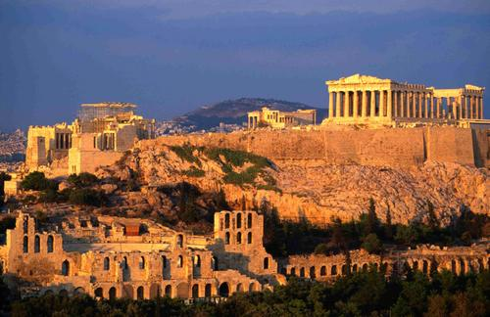
Figure. One figure, if you wish.

[1] One or two references, if you wish: authors, journal, year, volume, page

