Format of the Abstract (one-page maximum): Use A4 Paper Size with 2.5 cm (1 inch) Margins, Arial Font, and 1.15 Spacing

A. Author,* B. Author, C. Author (if more than one, presenting author first with *)

Address or Addresses, with Countries
Email: presentingauthor@address

The eighth North America-Greece-Cyprus Workshop on Paramagnetic Materials (NAGC 2018) will be held on June 18-21, 2018, in Sparta, Greece. The venue will be the Mystras Grand Palace Resort & Spa just outside Sparta and close to the Byzantine city of Mystras. The NAGC Workshops are held every two years, alternating between Cyprus and Greece. They were originally established to provide a regular forum for the faculty and students of universities in Greece and Cyprus to meet and interact with their North American counterparts, as well as a select few people from other European countries and elsewhere; however, they have since grown to become one of the most popular series of workshops involving North Americans and (European) Mediterranean countries. Following the outstanding success of the previous NAGC Workshops, we shall once again be organizing a broad program that will bring together a wide range of researchers working in diverse fields and applications who would not normally attend the same meeting. The program will span chemistry and materials science - both experimentalists and theorists, junior and senior - and will encompass any kind of study on any kind of system involving unpaired electrons (but the latter does not have to be a focus of the talk): molecular or non-molecular materials; organic, inorganic, or biochemical; ground state or excited state; solid, liquid, gas, or plasma. In fact, some talks involve no unpaired electrons at all, and that is okay too [1].

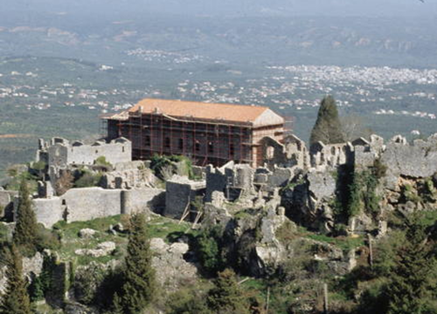
Figure. One figure, if you wish.
The lecture facilities and some workshop accommodation will be at the newly-built Mystras Grand Palace Resort & Spa on the outskirts of Sparta and not far from the ancient town of Mystras, a byzantine archeological area that is a UNESCO World Heritage Center. The workshop welcoming reception will be on the evening of June 17th.

[1] One or two references, if you wish: authors, journal, year, volume, page

