Prof. George Christou elected a Fellow of the American Chemical Society
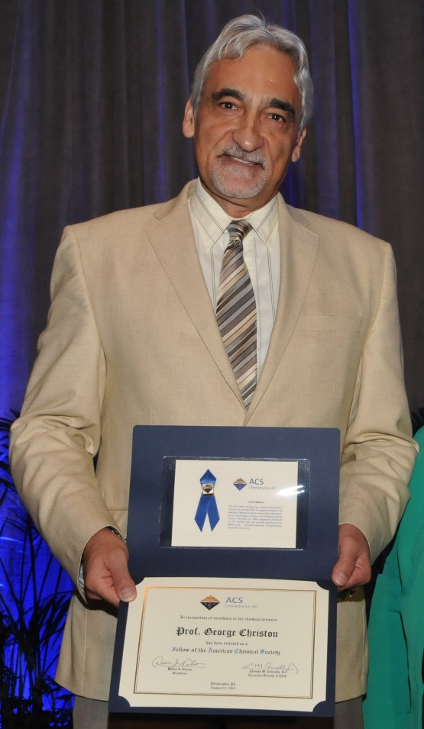
UF Distinguished Professor and Drago Chair of Chemistry George Christou has been elected a Fellow of the American Chemical Society. His name was included in the 2016 list of new ACS Fellows published in July in C&E News, and he recently attended the ceremony for new Fellows on August 22 at the ACS national meeting in Philadelphia. ACS Fellows are chosen “for outstanding achievements in and contributions to science, the profession, and the ACS community.” He is one of only two new ACS Fellows in the state of Florida.
Prof. Christou's research is in synthetic and physical-inorganic chemistry of the transition metals, and spans molecular nanomagnetism, bioinorganic chemistry, and supramolecular chemistry.

